**Brooklyn torah gazette**

**For parshas shelach 5782**

Volume 6, Issue 39 (Whole Number 294 26 Sivan/ June 25, 2022

**The Harlot Who Discovered**

**A Higher Satisfaction**

**By**[**Yossi Ives**](https://www.chabad.org/search/keyword_cdo/kid/9055/jewish/Ives-Yossi.htm)



**Illustrated by Sefira Lightstone**

The portion of Shelach concludes with the mitzvah of attaching tzitzit to the edges of a four-cornered garment. Why? “So that you may remember Him and fulfill His commandments.”[1](javascript:doFootnote('1a5553931');) To illustrate this, the Talmud[2](javascript:doFootnote('2a5553931');) tells of a man “who was meticulous about the observance of [tzitzit](https://www.chabad.org/multimedia/video_cdo/aid/2202007/jewish/String-Theory-Part-1.htm)” and who we later discover was actually a yeshiva student, who hears about an exquisite harlot operating on a distant island who charges 400 gold coins for her services. He sent her the money and booked his slot.

We wonder what a budding Torah scholar was doing engaging in this kind of pleasure. It also seems very unlikely that this man had this kind of money to spare, so what was he doing blowing such a vast sum on this adventure?

Rather, here was an individual who was living a regular life according to his pious leanings, but who began to question whether he was missing out on worldly pleasures. So he decided to pursue what seemed to him the most extravagant adventure into the world of sin. He would go all-out to experience the height of indulgence and see what it was about.

**A Chamber with Seven Beds**

He arrived at a palace, at the heart of which lay a chamber with seven beds, six of silver and one of gold. Each bed was higher than the next, and was reached via a ladder. At the very pinnacle lay the woman he had paid so much to visit.

Everything about the moment was designed to be overwhelming, overpowering the senses.

But just as he was disrobing, the fringes of his tzitzit slapped him in the face. As Rashi suggests, this was no coincidence. The Divine Hand was at work reminding him of who he was and what his values were. Stunned, the man slipped off the bed and slumped to the ground. The woman joined him there, confused by his sudden loss of interest. She said to him: “I swear by the life of the [Roman] emperor, that I will not let you go until you tell what fault you found in me [that made you lose interest].”

Said the man: “I swear that I have never seen a woman as beautiful as you. But, there is this unique commandment from G‑d called tzitzit …” He went on to explain the significance of the [mitzvah](https://www.chabad.org/library/article_cdo/aid/1438516/jewish/Mitzvah.htm) as a reminder of our fidelity to the Almighty, Who both rewards and punishes. Despite having shelled out so much money, and despite having traversed such great distances, being confronted by the message of the tzitzit stopped him in his tracks.

**The Ultimate in Physical Pleasure**

He had come to experience, at least once in his life, the ultimate in physical pleasure, only to discover that there is something that has an even greater pull on a person – their relationship to [G‑d](https://www.chabad.org/library/article_cdo/aid/433240/jewish/God.htm)! Despite the glamor and allure, even in the face of the promise of the pinnacle of human desire, he realized that there is something even more desirable – his Judaism; spiritual satisfaction.

The woman was shocked.“I shall not let you go unless you tell me your name, the name of your city, the name of your master, and the name of the [yeshiva](https://www.chabad.org/library/article_cdo/aid/4407857/jewish/What-Is-a-Yeshiva.htm) where you studied [Torah](https://www.chabad.org/library/article_cdo/aid/1426382/jewish/Torah.htm).” The man wrote down this information and handed it to her.

This is perhaps the most fascinating part of the story. How did this woman know that he had a rabbi and studied Torah? Given what he had come to do that day, his behavior was hardly that of a Torah student!

Perhaps even more perplexing is his willingness to divulge his identity, given the compromising situation he put himself in. Why would he agree to provide specific information that would make it so easy for his activities to become known to his own illustrious rabbi?

**Recognizing His Unique Inner Strength**

This woman knew the power she had over her clients. Never before had anyone displayed that level of self-control. She realized that only someone with unique inner strength would be able to resist temptation in the manner she had just witnessed. Only a person who had been inspired by Torah would have been so transformed by the sign of the tzitzit brushing against his face.

To her it was obvious that this had to be someone instilled with Torah values, someone who had studied in a yeshiva. She didn’t ask him *if* he had a rabbi, but *who* was his rabbi. Such a person doesn’t just happen, but is the product of years of investment.

For all of the embarrassing nature of the situation, this man knew that he had prevailed and had achieved greatness. He had nothing to hide; he had acquitted himself admirably. We can only speculate about what the man expected would happen next, but it is unlikely that he foresaw what was to transpire.

Amazed by what happened, the woman decided to make some changes to her own life. She gave a third of her wealth to the crown (in exchange for permission to convert), a third she distributed to the poor, and the remainder she took with her. She made her way to the yeshiva of the great Rabbi Chiyya, the man’s teacher. “Rabbi,” she demanded, “give the order that they should make me a convert [to Judaism].”

**That Which Was Prohibited Can**

**Now be Used in a Permitted Manner**

Rebbi Chiyya sensed that something about this was unusual. “Have you perhaps set your eyes upon one of my students?” Whereupon she produced the note given to her by the man, signaling that she had witnessed a miracle that had inspired her to discover Judaism. Rebbi Chiyya understood the enormous impact this encounter had on both of them. He acquiesced to her request for conversion, and gave his approval to the marriage. “Go, acquire your prize,” he told her. “Those sheets which you laid out for him in a manner that was prohibited, now you can lay them out for him in a manner that is permitted.”

This woman thought that she had the keys to true pleasure, only to discover that there is a happiness that trumps it. The power of what she had to offer was no match to spiritual strength. All the hype around her luster evaporated when confronted with the infinite appeal of that which is holy and pure. And now that she had decided to go in search of spiritual riches herself.

In a sense, that man could be any one of us. Perhaps our story is not quite as dramatic, but the theme is not so different. We can spend enormous amounts of effort and resources in pursuit of vain satisfaction, only to come to the realization that true and lasting happiness is attained through the grandeur of the soul.

**FOOTNOTES**

[1.](https://www.chabad.org/parshah/article_cdo/aid/5553931/jewish/The-Harlot-Who-Discovered-a-Higher-Satisfaction.htm" \l "footnoteRef1a5553931)[Numbers 15:41](https://www.chabad.org/9943" \l "v41).

[2.](https://www.chabad.org/parshah/article_cdo/aid/5553931/jewish/The-Harlot-Who-Discovered-a-Higher-Satisfaction.htm" \l "footnoteRef2a5553931)Talmud, Menachot 44a.

*Reprinted from this week’s website of Chabad.Org Magazine.*

**Rav Avigdor Miller on**

**Separating Boys and Girls**



**QUESTION: Should a boy have any friendship with girls?**

**ANSWER:** Now that question really is superfluous. The answer is N-O, no! That’s all. And the truth is not only no friendship; there should be no kirvah at all. No kind of closeness at all. You shouldn’t stop on the street to talk to a girl. If he meets a girl on the street and he wants to fulfill the mitzvah of being mekabel es kol adam beseiver panim yafos, no; it doesn’t apply to girls.

I was once, about forty years ago, in a country place with Satmarer chassidim, and we were saying kinos on Tisha Ba’av. So I said to chossid who was next to me, “The ladies out there are too far away. They can’t hear the kinos.” He said to me, “They’re not far away enough. The further away they are the better they are.” A piece of wisdom I heard from him.

Now don’t think he’s downgrading the ladies. No. He’s not scorning the ladies; but he recognizes the truth of nature. And don’t deceive yourself.

There’s a chapter in Shulchan Aruch that’s titled, “Lehisrachek min hanashim – keep away from women.” And women keep away from men. And that’s an ironclad rule. It’s a common sense rule. And once upon a time even lihavdil the goyim understood that themselves. That’s how important it is.

*Reprinted from June 19, 2022 email of Toras Avigdor. Adapted from Tape #867*

**The Erronious Logic of Spies Who Feared Entering the Promised Land**

**From the Talks of the Lubavitcher Rebbe**

**Rabbi Menachem Mendel Schneerson, Zt”l**



In this week's Torah portion, Shelach, the 12 spies return from their mission to the Land of Israel with a report that is deliberately discouraging. Why did the spies so desperately want to remain in the desert?

In the desert, the Jews led an extremely spiritual existence. For 40 years they did not have to concern themselves with worldly matters, as all of their physical needs were met in a miraculous manner. G-d provided them with manna from the heavens. Water was supplied by "Miriam's well." Even the need for clothing was taken care of, as their garments never wore out and grew with their bodies. For 40 years the Jewish people had the luxury of devoting themselves completely to a life of the spirit.

The spies realized that once they entered the land, an entirely new era would begin. No longer would the Jewish people eat manna; they would have to labor long and hard to derive bread from the earth. Their purely spiritual existence would cease, and the Jews would find themselves involved in more mundane tasks.

**“A Land Which Consumes its Inhabitants”**

It was for this reason that the spies described Eretz Yisrael as "a land which consumes its inhabitants." They warned that whoever will live there will likewise be turned into eretz -- preoccupied with worldly matters. The spies wished to prolong their purely spiritual service of G-d, a service uninterrupted by other pursuits. Thus they tried to dissuade the Jews from entering the land.

Unfortunately, the basic premise of the spies was erroneous. The world was created not for man to ignore the physical, but that he fashion "a dwelling place for G-d in the lower realms." G-d wants us to utilize every aspect of physical existence for the purpose of imbuing it with holiness, uncovering its hidden spirituality. The entire period of the Jewish people's wandering in the desert was only a preparatory stage before their entry into the land.

These two stages -- "desert" and "the land of Israel" -- are paralleled in the life of every Jew. There are times when a Jew is involved in spiritual pursuits, learning Torah and praying, and times when he must turn his attention to the more mundane task of earning a living.

**The Objective is to Imbue the**

**Physical World with G-dlliness**

However, a Jew mustn't think that it is necessary to cut himself off from the world, or aspire to lead a purely spiritual existence. Rather, the Jew's objective is to imbue the physical world with G-dliness. A Jew serves G-d even when he eats and drinks, provided he conducts himself according to the Torah. In this manner, each Jew fulfills the will of G-d, just as the Jewish people fulfilled G-d's will in entering the land of Israel.

*Reprinted from the Parshat Shelach 1997/5757 (Issue #474) edition of L’Chaim Weekly, a publication of the Lubavitch Youth Organization in Brooklyn, NY. Adapted from Likutei Sichot, Volume 4.*

**Rabbi Berel Wein on**

**Parshat Shelach 5782**



We are taught by a Mishnah in Avot that the Jewish people, as represented by the generation of the Sinai desert, tested the Lord 10 times. The idea of testing G-d is a difficult one to understand and appreciate. This is particularly so when we can see that this generation did not learn from experience. Each test in turn failed to achieve anything other than harming that generation and dooming it to destruction, never to enter the land of Israel.

The sending of the spies to discover and report back on the condition of our promised country and its population at the time is a prime example of this type of test. As Rashi points out, the L-rd told Moshe: “I am not ordering you to send spies to report on the land of Israel. I have told you that this land is your destiny and that it is a land of spiritual and physical greatness and prosperity.

However, if you wish, you have the option of sending spies”. Implicit in this choice, given from heaven, is that the option will be of great consequence if it is exercised. It is also a repetition of a test that the Torah has recorded for us many times, when the people ask themselves: “Is the Lord truly within our community or not?” If, after all the miracles that this generation experienced, the people could still bring themselves to ask: “is G-d within us or not?”, it must have been obvious that the people’s relationship with the creator was dysfunctional and that they did not share His program for their future.

The commentators have advanced many reasons over the ages as to what directly motivated the leaders of Israel to create such a crisis of faith within their people. However, the basic problem—as recorded repeatedly—is the fact that the people’s trust in G-d, no matter how many miracles and victories they experienced, was very weak and fragile.

Faith is one of the strongest emotions that a person can have. However, it is also something that can be hard to acquire but quite easy to abandon or lose. When faith wanes, the process of testing G-d, so to speak, begins anew; for it is in the nature of human beings to learn very little from their previous experiences.

There will always be excuses. We can say the previous test went wrong but now, with a test involving the right people on the right issue and with greater clarity, this will somehow help us. In their relationship to the land of Israel, the Jewish people have always had to struggle.

It was never easy to see the true purpose of the land of Israel for Jewish life, especially since the Jews could prove to be so successful outside of the land of Israel. Yet the centrality of the land of Israel to Judaism has always been one of the prime beliefs and national messages of the Torah regarding the survival and destiny of the Jewish people. Jews should not again fall into the trap of testing G-d regarding the land of Israel.

Shabbat shalom

*Reprinted from the current website of rabbiwein.com*

**The Power of a Seemingly Simple Navi (Prophet)**

**By Daniel Keren**

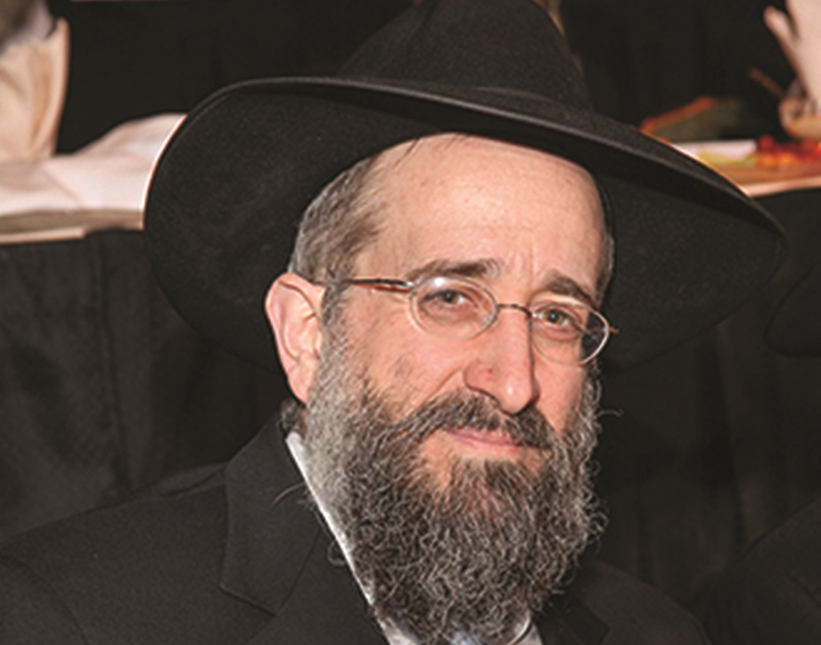

**Rabbi Yisroel Reisman**

An enthusiastic crowd of men and women off from work on the recent legal holiday of Memorial Day - joined by many retirees took advantage of the half-day Hakhel Yarchei Kallah Event at the Agudath Israel of Madison in Flatbush that was offered free of charge. Hakhel is an organization devoted to promoting Torah-true values in our community.

Rabbi Yisroel Reisman, mora d’asra of the host shul began the Yarchei Kallah program with the first lecture in a new series of legal day shiurim on Amos, the third book in Sefer Trei Asar, the Twelve Minor Prophets, one of the 24 books in Tanach (the Jewish Bible). The theme of his discussion was an introduction on the Prophet was titled “Amos, the Navi Hashem.”

Rabbi Reisman began by asking the question of who was Amos? The Book of Amos begins with the information that the Prophet Amos is a shepherd from Tekoa. Tekoa is a community in the tribal territory of Asher. The navuah (prophecy) of Amos was primarily for the northern kingdom of Israel (the Ten Tribes) and not necessarily for the southern tribes of Yehuda and Binyomin.

**A Navi from a Much Simpler Background**

The prophecy of the Navi Amos began about 65 years before the Ten Tribes were captured and exiled from Eretz Yisroel (the Land of Israel) by the Assyrian Empire. The image we have, Rabbi Reisman of Amos is of a Navi who came from a much simpler background than that of the other naviim (prophets) of that time period.

It appears that Amos was a stutterer and one who had a difficult time expressing himself. But he was nevertheless chosen to deliver an important prophecy to the Jewish people that was destined to be preserved [in the Tanach, the Jewish people] for all times.

Also, the first pasuk (verse) of the Book of Amos informs us that his prophecies began during the reigns of Uzziah, the tenth king of Yehuda (the House of Dovid) and Yeravam, king of the Israel (the Ten breakaway Tribes) some two years before the earthquake.

**The Serious Mistake of King Uzziah**

Uzziah was a king [from Yehuda] who made the serious mistake of thinking that he could [simultaneously] serve as the Kohen Gadol (Chief Priest). At the moment Uzziah tried to do the service of the Kohen Gadol, he was struck with a debilitating tzaras (spiritual leprosy). At that moment, a major earthquake erupted.

Rabbi Reisman pointed out that both the Abarbanel (Rabbi Yitzchak ben Yehudah Abarbanel, 1437-1508) and the Radak (Rabbi Dovid Kimchi, 1160-1235) in their commentaries say that Amos only gave navuah for two years.

The Abarbanel also takes the Rambam (Rabbi Moses ben Maimonides, 1138-1204) to task for his inclination for too much philosophy. As a result, he writes that no one can become a Navi (Prophet) without preparing himself for this task. The Rambam argues that one can’t go to sleep when not a Navi and just wake up the next morning as a brand-new Navi. The Abarbanel criticizes this position of the Rambam, claiming that he was too influenced by the ancient Greek philosopher Aristotle (384-322 Before the Common Era).

The Rambam says that one who wants to be a navi should separate himself from too many physical or mundane pleasures. And one can only achieve prophecy if one lives in Eretz Yisroel, since one who doesn’t live in the holy land has to be unhappy and therefore uncapable of developing into becoming a holy prophet. This position by the Rambam is strongly disputed by the Abarbanel.

**There are Two Types of Naviim (Prophets)**

The Malbim (Rabbi Meir Leibush Wisser, 1809-1879) teaches that there are two types of Naviim. The first are those 48 Naviim whose prophecies were preserved for all generations [as recorded in the Tanach.] Such prophets can be sent for their special missions by Hakodesh Baruch Hu (the Holy One blessed be He) without any particular preparations on the part of the individual naviim.

The second type of Jewish prophets numbered in the millions in Jewish history [until the end of prophecy shortly after the destruction of the First Beis Hamikdosh (Holy Temple) in Yerushalayim (Jerusalem). These individuals who delivered navuah (prophecies) were the result of meticulous spiritual preparation, even though their prophetic messages were for only that generation in which the second type of Navi lived [and thus not preserved in Tanach for all subsequent generations of the Jewish people.]

Rabbi Reisman says that the Navi Amos was not chosen by Hakodesh Baruch Hu because he was a talmid chacham (Torah scholar). Why then was he chosen. We are not privy to know.

**The Significance of the Fourth Verse**

Concerning the third verse of the first chapter of Amos that begins “Koh Amar Hashem/for thus says Hashem”, Rabbi Reisman noted the significance of the fourth verse. Amos declares that Hashem forgave Damasek (the non-Jewish people of Damascus) for their sinning three times. But their fourth sin, Hashem will not forgive the people of Damasek, promising “to break the bar of Damasek.”

Similarly, the Navi Amos prophesizes Hashem’s promise to similarly punish the non-Jews of Gaza, Edom, Ammon and Moav. Yet, what depresses Rabbi Reisman was the navuah of Amos that Hashem is also going to punish the people of Yehuda and the people of Israel (the Ten Tribes) after forgiving them for their initial three sins against Him.

How can we understand this? Rabbi Reisman found an interesting teaching from the Haggadah of the Gra (the Vilna Gaon, Rabbi Eliyahu ben Shlomo Zalman, 1720-1797). The Gra points out that whenever you have a number of four things, the first is separate from the second and the third and fourth are connected to each other. For example, there are four Imahos (Matriarchs in the Jewish nation.) Sarah the wife of Avraham is completely separate from Rivka, the wife of Yitzchok. Yet we find that Leah and Rochel (the third and four of the Matriarchs) are connected in that they are both the wives of Yaakov.

**The Four Meals Connected to Shabbos**

Another example are the four meals (seudas) related to Shabbos. The first seuda is connected to the Friday night meal and the second seuda on Shabbos day is completely separate from the Friday night meal. The Mishna Berura (written by the Chofetz Chaim, Rabbi Yisroel Meir Kagan, 1838-1933) explains that if one eats Shalosh Seudah (the third meal) after Mincha and is still eating into the evening [before bentching and davening Maariv to end Shabbos], one can therefore be yotzei [fulfilled] one’s obligation to eat the Melava Malkah meal on Motzei Shabbos (Saturday night).

So, while Amos’s prophecies is one of dire punishment to Klal Yisroel, it is also at the same time a navuah of hope. The worst thing is for a Jew to surrender completely to despair. If, however, one regrets and does sincere teshuvah (repentance), his spiritual failures can be erased. True teshuva can even cause his past sins to be elevated [to kedusha or the level of actually being transformed into the level of a mitzvah.]

Rabbi Reisman emphasized that the prophecies of Amos warns of the danger of falling into the habit of spiritual failures. The Rambam explains that Amos was a simple man – a shepherd from Tekoa. Yet, it is because Amos was such a simple individual that as a Navi he was able to relay the message to the Jewish people of all times that one can indeed break his negative habits and successfully come back to Hashem and be forgiven and accepted again by G-d as though nothing wrong had been done.

*Reprinted from the June 16, 2022 edition of The Flatbush Jewish Journal.*

